A Research Proposal Report on
Development and Validation of Contactless Internet of Things based Frameworks for Fatigue Detection and Tracking in Warehouse Environments
(On partial fulfilment of the course BB 701)

by
Aritra Das
Roll No: 25D0074

Under the supervision of
PROF. AMBARISH KUNWAR



Department of Biosciences and Bioengineering
Indian Institute of Technology Bombay
Mumbai, Maharashtra

Acknowledgement

I would like to express my sincere gratitude to Prof. Ambarish Kunwar for helping me select the topic for research proposal.
I would also like to thank all the members of my lab, especially Binil and Nayanthara for spending extensive amounts of time discussing the research proposal with me. The discussions helped me refine my approach towards the research topic and define the specific objectives.

Keywords:
Fatigue detection; IoT; Warehouse occupational safety; Edge computing;

Graphical Abstract:

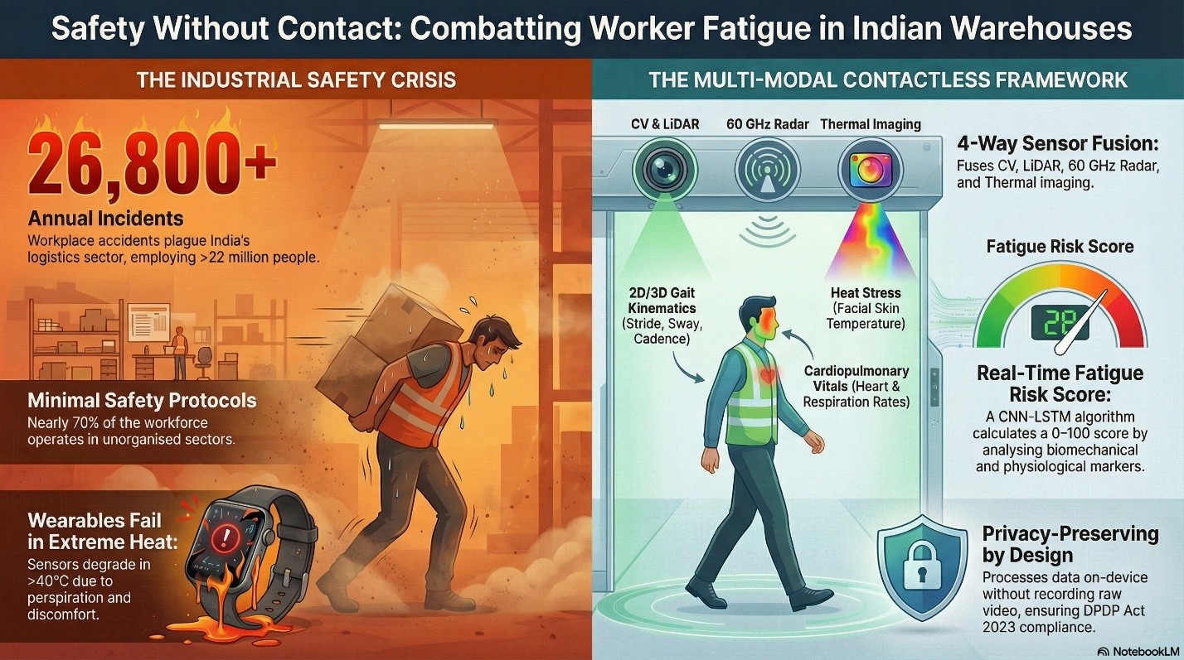
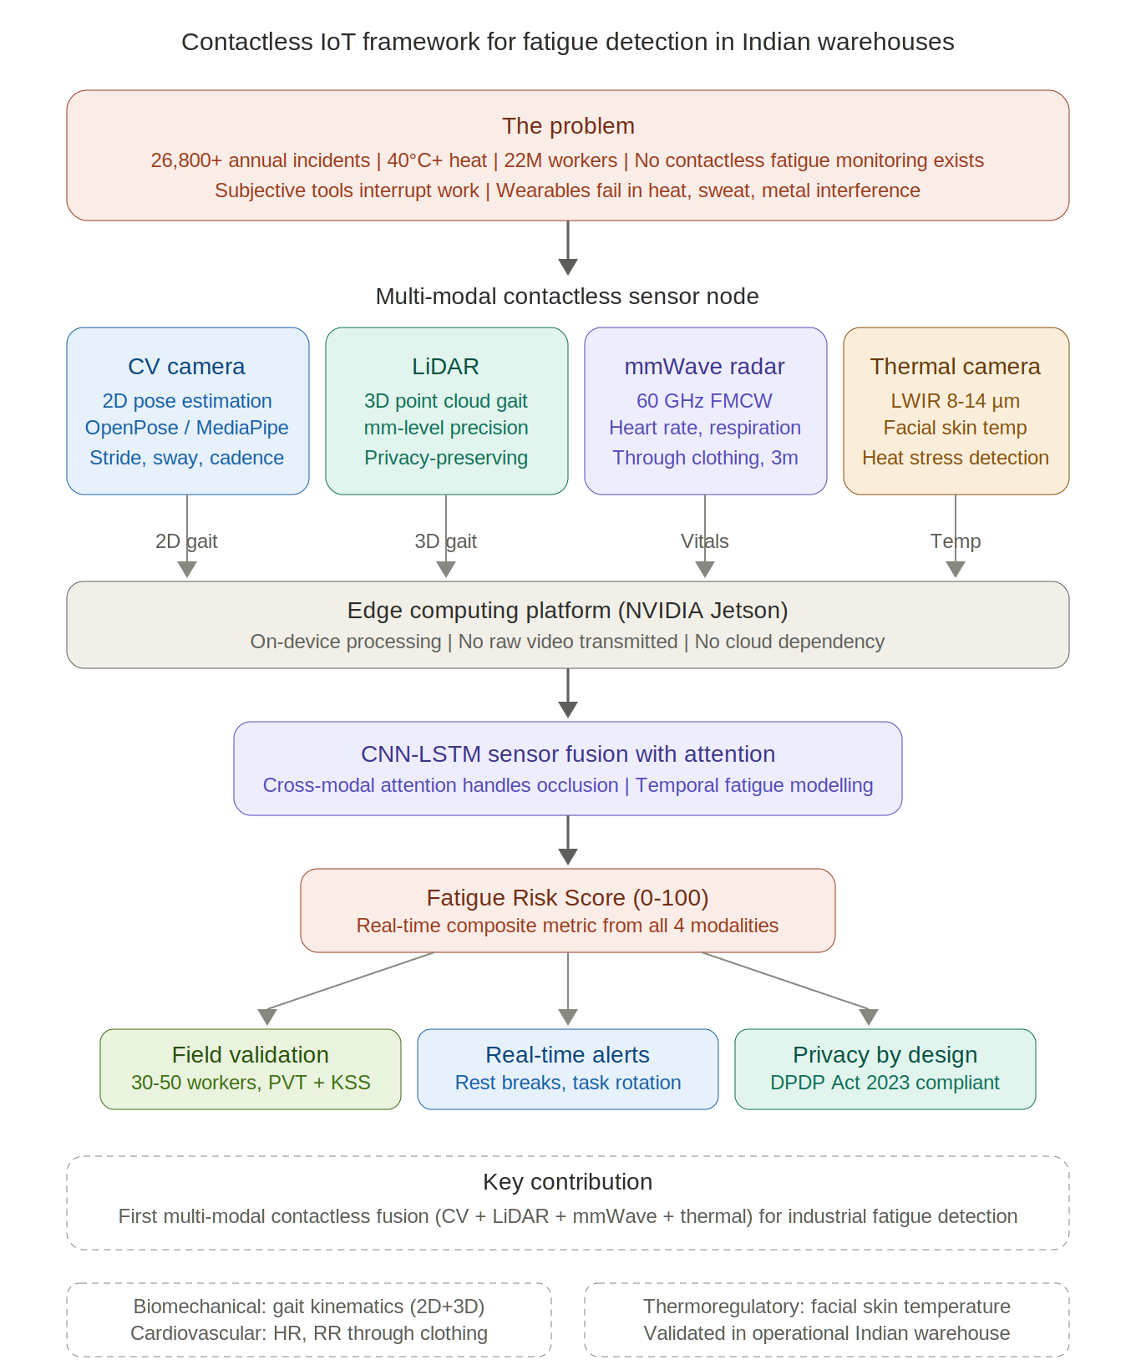

Abstract:
Worker fatigue is a leading cause of workplace accidents in India’s logistics sector, which employs over 22 million people and has recorded more than 26,800 incidents annually. Current detection methods heavily rely on subjective self-report tools that interrupt work or wearable biosensors that face severe adoption barriers in tropical warehouse environments, including heat-related discomfort, signal degradation from perspiration, and worker resistance to body-worn devices. Contactless sensing technologies have individually matured to high accuracy, but remain fragmented across isolated research domains. No study has yet fused multiple contactless ambient sensors for whole-body physical fatigue detection, especially in an unorganized industrial environment. This proposal aims to develop and validates a multi-modal contactless IoT framework for real-time fatigue monitoring in Indian warehouses. The system integrates edge-AI cameras for 2D gait extraction, LiDAR for 3D gait kinematics, 60 GHz FMCW radar for cardiopulmonary vital sign monitoring, and thermal imaging for heat stress detection, all processed on a single edge computing platform. A sensor fusion algorithm aggregates these heterogeneous data streams into a composite Fatigue Risk Score. The framework will be validated through field deployment in an operational Indian warehouse with 30 to 50 workers across multiple shifts, benchmarked against gold-standard Psychomotor Vigilance Test and Karolinska Sleepiness Scale assessments. The privacy-preserving architecture employs LiDAR point clouds, radar micro-Doppler signatures, and on-device skeletal extraction rather than raw video transmission, ensuring compliance with India’s Digital Personal Data Protection Act 2023. This work addresses a critical unoccupied gap at the intersection of contactless sensing and industrial occupational safety.

Origin of Proposal:
India’s logistics and warehousing sector employs over 22 million workers and is expanding rapidly under the National Logistics Policy 2022. However, this growth has brought a critical occupational safety challenge: widespread worker fatigue. In Indian warehouses, where ambient temperatures routinely exceed 40°C and shifts extend to 10 to 12 hours, fatigue is a leading cause of workplace accidents, with the sector recording over 26,800 incidents annually. Nearly 70% of the workforce operates in the unorganized sector, where occupational health and safety protocols are minimal or absent.
Current fatigue detection methods fall into two broad categories. The first is subjective assessment, where tools such as the Karolinska Sleepiness Scale (KSS) and the Psychomotor Vigilance Test (PVT) require active worker participation, interrupting workflow and depending on compliance. The second is wearable-based physiological monitoring, where devices such as PPG-based smartwatches, chest-strap heart rate monitors, sEMG sensors, and IMU-equipped bands can objectively track fatigue-related markers including heart rate variability, muscle activation, and gait kinematics. However, wearables face severe adoption barriers in the Indian warehouse context: physical discomfort in extreme heat, worker resistance due to surveillance anxiety, signal degradation from excessive perspiration, and the logistical burden of charging thousands of devices daily. Dense metal racking also disrupts low-power Bluetooth communication, causing frequent data loss.
A third category, contactless sensing, has matured significantly in recent years but remains fragmented. Computer Vision (CV) pose estimation algorithms (OpenPose, MediaPipe) can extract gait and posture parameters from camera feeds. LiDAR sensors can generate dense 3D point clouds for millimetre-accurate gait kinematics while being inherently privacy-preserving. Millimetre-wave (mmWave) radar at 60 GHz can detect chest wall micro-vibrations through clothing to estimate heart rate and respiration rate. Thermal cameras can remotely measure skin surface temperature as an indicator of heat stress. However, each of these modalities has been validated only in isolation, predominantly in controlled laboratory settings or for driver drowsiness detection using facial features (PERCLOS, eye closure, yawning), which are not transferable to mobile industrial workers whose fatigue manifests through whole-body biomechanical and physiological changes rather than facial cues.
A critical gap therefore exists at the intersection of contactless sensing and whole-body physical fatigue detection in industrial workers. While wearable-based systems (sEMG, IMU, PPG) have demonstrated that physical markers of fatigue, including gait deterioration, elevated heart rate, and altered muscle activation patterns, can be objectively measured, they require on-body instrumentation that is impractical at scale. Meanwhile, contactless sensing technologies have individually matured to high accuracy in controlled settings, but no study has attempted to fuse multiple contactless ambient sensors for fatigue detection in uncontrolled industrial environments. Furthermore, all existing contactless fatigue research is limited to driver drowsiness (facial feature analysis) or laboratory gait studies, neither of which is transferable to mobile warehouse workers operating under extreme heat, dust, occlusion, and electromagnetic interference from metal shelving. No system, whether Indian or international, occupies this space. This proposal aims to fill that gap by developing and validating a multi-modal contactless IoT framework for real-time fatigue detection in operational Indian warehouse environments, shifting the paradigm from on-body sensing to in-environment sensing to deliver a scalable, privacy-compliant, wearable-free safety solution tailored to the Indian logistics sector.

Rationale/Gaps in Existing Knowledge, Key Questions and Hypothesis:

What is Physical Fatigue?
Physical fatigue is a complex, multi-system physiological phenomenon characterised by a progressive reduction in the capacity to sustain or generate muscular force and power, arising from prolonged exertion of the musculoskeletal system. It is distinct from cognitive or mental fatigue, though both often co-occur in occupational settings and their effects on worker safety are cumulative. At the whole-body level, physical fatigue manifests simultaneously across multiple physiological systems: neuromuscular deterioration (reduced motor unit recruitment, increased muscular co-contraction), cardiovascular strain (progressive heart rate elevation at a constant workload, declining heart rate variability), thermoregulatory stress (rising core and peripheral skin surface temperature), and biomechanical degradation (increased gait variability, reduced stride length, greater trunk sway, declining Minimum Toe Clearance). Occupational safety authorities including the National Institute for Occupational Safety and Health (NIOSH) have identified fatigue as a primary risk factor for workplace incidents in manual material handling roles such as warehouse work, where whole-body fatigue arises from a combination of sustained physical exertion, extreme ambient heat, and prolonged shift duration.
While physical and cognitive fatigue are physiologically distinct, prolonged physical exhaustion has been shown to degrade psychomotor vigilance and reaction time. Angius et al. (2022) demonstrated in a controlled study that physical fatigue significantly reduced response speed on the Psychomotor Vigilance Test (PVT), and that physical and mental fatigue exert negative cumulative effects on sustained attention. This establishes PVT as an accepted, if indirect, validator of physical fatigue states in occupational research, a distinction that is relevant to the validation strategy proposed below.

Current Methods for Detecting Fatigue
Detection approaches fall into three broad categories, each with significant limitations for continuous industrial deployment.
Subjective tools such as the Karolinska Sleepiness Scale (KSS), the Borg Rating of Perceived Exertion (RPE), and the Psychomotor Vigilance Test (PVT) remain the accepted gold standards in fatigue research. PVT provides an objective measure of sustained attention through reaction time and is sensitive to both sleep deprivation and physical exhaustion. However, these tools require the worker to stop working and actively perform a task or answer questions. In a warehouse setting where 200 to 500 workers may be active on a single shift, administering PVT at regular intervals is operationally infeasible. They are indispensable for research validation, but they are not scalable as deployment solutions.
Wearable physiological monitoring has partially addressed the continuity problem. PPG-based wrist devices track heart rate variability as an indirect fatigue indicator. sEMG sensors measure muscle fatigue directly through the progressive shift of the power spectrum toward lower frequencies (median frequency decline) as motor unit firing patterns deteriorate. IMU-equipped bands quantify gait kinematics and postural sway. Biochemical markers such as blood lactate and salivary cortisol can also indicate metabolic fatigue load, though they require periodic invasive sampling and are not suitable for continuous monitoring. A recent study combining sEMG and IMU data through a CNN-LSTM-Attention architecture achieved 87.94% accuracy in classifying gait-based fatigue states using rigorous Leave-One-Subject-Out Cross-Validation (Hwang et al., 2025), demonstrating that physical markers captured by body-worn sensors can reliably indicate fatigue across individuals. Papoutsakis et al. (2021), working within the EU sustAGE project, fused camera-based posture assessment with smartwatch heart rate data and found that imposing increased physical strain results in a measurable heart rate increase after 100 to 120 seconds of sustained exertion. These results confirm that fatigue leaves measurable traces across multiple physiological systems simultaneously. However, wearables carry well-documented adoption barriers in the Indian warehouse context: discomfort in hot and humid conditions exceeding 40\u00B0C, signal degradation from excessive perspiration, worker resistance to perceived surveillance, device charging logistics at scale, and Bluetooth communication failures in metal-dense environments. These are not minor inconveniences; they are fundamental deployment blockers in a sector where the unorganized workforce dominates and digital literacy among workers is minimal.
Contactless sensing technologies, taken individually, have reached impressive technical maturity but have not been applied to industrial fatigue monitoring. Computer Vision algorithms (OpenPose, MediaPipe) can extract gait and posture from camera feeds. LiDAR provides millimetre-accurate 3D body kinematics without any identifiable imagery. Multiple groups have demonstrated that mmWave FMCW radar can estimate respiration rate with accuracy exceeding 95% and heart rate with accuracy exceeding 90% against contact-based ECG references at distances up to 2 metres under quasi-static conditions (Ahmad et al., 2018; Alizadeh et al., 2019; Benny et al., 2023), and LiDAR-based gait recognition has been shown to significantly outperform camera-based methods under occlusion and poor illumination (Shen et al., 2023). Thermal cameras can remotely measure facial skin surface temperature, with forehead and periorbital regions showing the earliest thermal response to heat stress and physical exertion (Bordallo L\u00F3pez et al., 2017; Perpetuini et al., 2022). Indian field studies by Venugopal et al. have documented that over 90% of WBGT measurements in Southern Indian steel industries exceed recommended thresholds, confirming that heat stress is a compounding fatigue factor in tropical industrial settings. Each of these modalities has been validated in isolation, but no system has fused them for fatigue detection in active industrial workers under uncontrolled conditions. The following subsections articulate the specific knowledge gaps this proposal addresses.

Gaps in Existing Knowledge
First, to the best of our knowledge, no study has attempted multi-modal fusion of contactless ambient sensors for fatigue detection. Existing multi-modal fatigue work is limited to the driver drowsiness domain (combining facial cameras with EEG) or controlled laboratory gait analysis (sEMG + IMU). Neither is transferable to active industrial workers who are mobile, frequently occluded, and operating in environments with dust, heat, and electromagnetic interference. The fusion of CV, LiDAR, mmWave radar, and thermal imaging for fatigue detection remains an unexplored research space. Second, all existing contactless monitoring research has been validated in laboratories or in domains (automotive, healthcare, construction) that differ fundamentally from the Indian warehouse context. No system has been tested under the specific combination of temperatures exceeding 40C, airborne particulates, dense metal shelving causing occlusion and radar multipath interference, and a workforce with minimal digital literacy. Third, India has growing but disconnected capabilities in mmWave radar sensing (IC-WiBES, IIIT Hyderabad), computer vision (IIT Kanpur, IIT Hyderabad), and occupational heat stress epidemiology (NIOH, Ahmedabad). No Indian research group has integrated these competencies into a unified worker monitoring framework. Fourth, existing workplace monitoring systems globally do not incorporate privacy-preserving design as an architectural principle. India's DPDP Act 2023 mandates purpose limitation and data minimisation but provides no specific protections for biometric data, creating regulatory ambiguity that any monitoring system deployed in Indian workplaces must address proactively.

Key Research Questions
These gaps lead to three key research questions.
1) Does multi-modal sensor fusion of contactless modalities (2D+3D gait, cardiopulmonary vitals, thermal) outperform individual sensing modalities in detecting physical fatigue in active warehouse workers?
2) Can a privacy-preserving edge-first architecture process and fuse multi-sensor data in real time while ensuring compliance with India's DPDP Act 2023?
3) What is the correlation between a contactless Fatigue Risk Score derived from ambient sensors and established gold-standard fatigue assessments (PVT, KSS) in an operational Indian warehouse?
Hypothesis
We hypothesize that the fusion of contactless sensing modalities, namely Computer Vision-based pose estimation, LiDAR-based 3D gait tracking, 60 GHz mmWave radar-based cardiopulmonary monitoring, and thermal imaging-based skin temperature measurement, can detect and quantify physical fatigue in active warehouse workers, achieving strong correlation with PVT and KSS assessments. We further hypothesize that fatigue manifests as a correlated, multi-domain physiological signature: simultaneous deterioration in gait regularity, elevation in heart and respiration rates, and rise in facial skin temperature. A sensor fusion approach capturing these complementary dimensions will significantly outperform any single-modality system under the uncontrolled, occluded, and high-temperature conditions of Indian warehouse environments.
The Relevance of the Proposed Study:
Workplace fatigue costs the Indian logistics sector thousands of preventable injuries each year, yet no continuous monitoring system exists that can operate without attaching devices to workers. This proposal is directly relevant because it targets a problem that current approaches cannot solve at scale. Subjective tools interrupt work and depend on compliance. Wearables degrade in hot, sweaty conditions and face resistance from a workforce with minimal digital literacy. The proposed contactless framework eliminates both barriers by embedding sensing capability into the environment itself.
The relevance extends beyond the immediate warehouse application. India’s DPDP Act 2023 has created regulatory uncertainty around workplace monitoring, particularly for systems that capture biometric data. The privacy-preserving architecture proposed here, using LiDAR point clouds, radar micro-Doppler signatures, and on-device skeletal extraction rather than raw video, offers a practical compliance template that does not yet exist in Indian industry or regulation. This has implications for any sector considering worker monitoring under the new data protection regime.
The project also bridges a disconnect in India’s research landscape. Strong but isolated capabilities exist in mmWave radar, computer vision, and occupational heat stress epidemiology across institutions like IIIT Hyderabad, IIT Kanpur, and NIOH Ahmedabad. Integrating these into a unified framework creates value that none of them can deliver independently.
The Expected Outcome of the Proposed Study:
The project shall produce the following tangible deliverables across its three objectives:
- Outcome 1 (Hardware Prototype): A functional, deployable multi-modal contactless sensor node combining CV, LiDAR, 60 GHz mmWave radar, and thermal imaging, calibrated to operate reliably in 40°C+ industrial environments without thermal throttling.
- Outcome 2 (Algorithm): A validated; edge-optimized asynchronous CNN-LSTM sensor fusion algorithm capable of generating a real-time Fatigue Risk Score (0–100) by weighing high-frequency kinematics against slow-moving physiological states.
- Outcome 3 (Field Evidence): The first empirical field dataset correlating contactless multi-sensor data against both cognitive (PVT, KSS) and objective physical (sEMG, IMU) ground-truth markers in a cohort of 30–50 Indian warehouse workers.
- Outcome 4 (Regulatory Framework): A documented, open-source “DPDP-Compliant Industrial IoT Data Pipeline Standard” demonstrating how to extract biomechanical safety metrics via edge-inference without generating or transmitting legally restricted biometric personal data.

Preliminary Work Done:
The preliminary work for this proposal involved an extensive literature survey spanning sensor modality performance, multi-modal fusion architectures, occupational fatigue physiology, Indian industrial environmental conditions, and data privacy compliance under the DPDP Act 2023.The technical feasibility of the proposed framework is supported by independently validated results from the published literature, which are discussed in the Origin and Rationale sections above. Each of the four sensing modalities (CV pose estimation, LiDAR gait recognition, mmWave radar cardiopulmonary monitoring, and thermal imaging for heat stress) has been individually demonstrated to high accuracy by established research groups, and multi-modal sensor fusion using CNN-LSTM architectures has been shown to outperform single-modality baselines in related fatigue detection tasks.

Aims/Objectives:

The aim of this project is to develop and validate a contactless, privacy-preserving IoT framework for real-time detection and tracking of physical fatigue in Indian warehouse workers, eliminating the need for wearable devices or active worker participation. This aim is pursued through three specific objectives:
Objective 1: Design and develop a multi-modal contactless IoT sensor node integrating edge-AI cameras, LiDAR, 60 GHz mmWave radar, and thermal imaging for detecting fatigue-related biomechanical and physiological markers at operational distances of 1 to 5 metres under Indian warehouse conditions (heat, dust, occlusion, electromagnetic interference from metal shelving).
Objective 2: Develop a sensor fusion algorithm aggregating 2D + 3D gait kinematics, cardiopulmonary vital signs, and skin temperature data into a composite real-time Fatigue Risk Score, and benchmark its performance against individual single-modality baselines to quantify the gain from multi-modal fusion.
Objective 3: Validate the framework against gold-standard fatigue assessments (Psychomotor Vigilance Test, Karolinska Sleepiness Scale) and contact-based physiological references (sEMG, IMU) through field deployment in an operational Indian warehouse, evaluating correlation strength, real-time processing feasibility, and privacy compliance under India’s DPDP Act 2023.

Research Strategy:
The research strategy is organized around the three objectives of this proposal. Each objective is described with its methodology, experimental protocols, validation criteria, and expected outputs.
Objective 1: Design and develop a multi-modal contactless IoT sensor node for detecting fatigue markers at 1 to 5 metres under Indian warehouse conditions.
This objective covers the hardware design, integration, and individual sensor validation phase. The goal is to assemble a single sensor node that houses all four modalities on one platform, calibrate each sensor independently, and verify that each can reliably extract its target fatigue markers under the specific environmental stressors present in Indian warehouses: temperatures exceeding 40°C, airborne dust, dense metal shelving causing visual occlusion and electromagnetic multipath interference, and continuously moving workers.
Sensor Selection and Hardware Integration
Computer Vision (CV) Module: An edge-AI camera (NVIDIA Jetson Orin Nano paired with an IMX477 global-shutter camera) configured to capture video at 30 FPS and 1080p resolution. On-device inference will run MediaPipe Pose or a lightweight OpenPose variant optimized through Jetson TensorRT, extracting 33 body keypoints per frame. The gait features derived from this module include stride length, step cadence, knee flexion angle, trunk sway amplitude, and arm swing asymmetry. Stenum et al. (2021) have shown that OpenPose achieves mean joint angle errors below 5° against marker-based motion capture, and MediaPipe has been demonstrated to sustain 25+ FPS on Jetson hardware. Only skeletal keypoint coordinates will be transmitted beyond the edge device; no raw video frames leave the sensor node.
LiDAR Module: A solid-state 3D LiDAR sensor (such as the Livox Mid-360, >100,000 points per second) co-located with the camera to generate dense 3D point clouds within the 1 to 5 metre operational range. The point cloud processing pipeline will employ 3D human body segmentation using PointNet++ to extract volumetric gait features: 3D stride length, step width, joint angles in three dimensions, and centre-of-mass trajectory. Shen et al. (CVPR 2023) demonstrated that point cloud-based gait features outperform camera-based methods under occlusion and variable illumination. LiDAR output is inherently non-identifiable since point clouds capture body geometry without facial features or skin texture.
mmWave Radar Module: A 60 GHz FMCW radar (such as the Texas Instruments IWR6843AOP) for contactless cardiopulmonary monitoring. The radar detects chest wall micro-vibrations through clothing at distances up to 3 metres. Signal processing involves range-FFT and Doppler-FFT to isolate chest displacement, followed by bandpass filtering to separate respiratory (0.1 to 0.5 Hz) and cardiac (0.8 to 2.0 Hz) components. Heart rate and respiration rate will be estimated through peak detection or MUSIC algorithms. Multiple groups have demonstrated >95% respiration rate accuracy and >90% heart rate accuracy against contact ECG at comparable distances (Ahmad et al., 2018; Alizadeh et al., 2019; Benny et al., 2023). Beamforming will isolate individual subjects when multiple workers are present.
Thermal Imaging Module: A long-wave infrared camera (8 to 14 µm spectral range, such as the FLIR Lepton 3.5) capturing at 8 to 9 FPS. Region-of-interest extraction will target the forehead and periorbital regions, which show the earliest thermal elevation under heat stress (Bordallo López et al., 2017; Perpetuini et al., 2022). Skin temperature readings will be calibrated against ambient temperature and humidity using a co-located environmental sensor (BME280) to differentiate genuine physiological heat stress from elevated ambient temperature.
Edge Computing Platform and Thermal Management: The simultaneous processing of four high-bandwidth sensor streams (1080p video at 30 FPS, >100K LiDAR points/second, continuous 60 GHz radar IF signals, and LWIR thermal frames) demands substantial computational and memory bandwidth. Published benchmarks on multi-sensor fusion for autonomous systems indicate that even high-end embedded platforms experience significant performance degradation under concurrent LiDAR and camera processing loads. Accordingly, the primary edge computing platform will be the NVIDIA Jetson AGX Orin (up to 275 TOPS, 64 GB LPDDR5 memory), rather than the entry-level Orin Nano, to ensure sufficient headroom for concurrent inference across all four modalities plus the fusion model. The Orin Nano may be used as a secondary development and testing unit.
Deployment in non-air-conditioned warehouses where ambient temperatures exceed 40°C introduces a critical thermal throttling risk. The Jetson Orin SoC is rated to a maximum junction temperature of 105°C, beyond which hardware thermal throttling forces clock speed reduction to prevent physical damage. Standard developer kit heatsinks are insufficient for sustained full-load operation at 40°C ambient. The sensor node enclosure will therefore incorporate an industrial-grade fanless thermal management solution with extended heat-sink fins rated for ambient temperatures up to 55°C, ensuring stable, non-throttled inference rates over continuous 8-hour shifts.

Sensor Node Assembly and Synchronization
All four modules will be mounted on a single bracket designed for ceiling or pillar installation at 2.5 to 3.5 metres height, angled downward to capture a monitoring zone approximately 3 metres wide by 5 metres long. A hardware trigger line from the Jetson processor will synchronize camera frame capture with LiDAR scan initiation and radar chirp transmission, targeting less than 10 ms inter-sensor synchronization error. The thermal camera, operating at a lower frame rate, will be temporally interpolated to align with the higher-rate CV and LiDAR streams.
Individual Sensor Validation in Controlled Laboratory Setting
Before field deployment, each modality will be validated independently. CV and LiDAR gait extraction will be compared against a marker-based motion capture system across walking trials performed by 10 to 15 volunteers at varying speeds and with simulated fatigue (treadmill exhaustion protocol). Yoshino et al. (2004) demonstrated that fatigued individuals exhibit two distinct compensatory strategies: some proactively reduce walking speed to maintain stability, while others maintain baseline speed at the cost of significant gait instability, with localized fatigue at the tibialis anterior preceding detectable gait rhythm changes. These findings inform the fatigue induction protocol and the expected range of biomechanical responses during validation trials. mmWave radar estimates will be validated against a contact ECG chest strap and respiratory belt. Thermal readings will be compared against a medical-grade infrared thermometer. Acceptance thresholds for proceeding to Objective 2: gait parameter extraction error below 10% relative to motion capture, vital sign correlation above 90% against ECG, and thermal accuracy within ±0.5°C of contact reference.
Critically, a subset of volunteers will simultaneously wear contact-based sEMG sensors (on the tibialis anterior and gastrocnemius) and IMU bands during the gait validation trials. This provides an objective physical fatigue ground truth, replicating the protocol used by Hwang et al. (2025), against which the contactless gait and vital sign measurements can be directly correlated. This dual-validation approach addresses the methodological concern that PVT and KSS, which primarily measure cognitive alertness and subjective sleepiness, may not fully capture the biomechanical dimensions of fatigue that the contactless sensors are designed to detect.

Objective 2: Develop a sensor fusion algorithm aggregating 2D + 3D gait, cardiopulmonary vitals, and skin temperature into a real-time Fatigue Risk Score.
This objective is the core algorithmic contribution of the project. It addresses the question of whether fusing heterogeneous contactless sensor streams produces a fatigue detection capability that exceeds what any single sensor can achieve alone.
Feature Engineering and Temporal Windowing
The raw sensor outputs will be transformed into a unified feature representation. Each monitoring pass (a single traversal of the monitoring zone, typically 5 to 10 seconds) will produce a feature vector from all four modalities. From the CV module: mean stride length, stride length variability (coefficient of variation), mean knee flexion angle, trunk sway amplitude, and arm swing asymmetry index. From LiDAR: 3D stride length, step width, 3D joint angle trajectories, and centre-of-mass vertical oscillation. From mmWave radar: instantaneous heart rate, respiration rate, and heart rate variability metrics (RMSSD, SDNN) over a 30-second sliding window. From the thermal camera: mean facial skin temperature, forehead-to-cheek temperature gradient, and rate of temperature change over 5-minute intervals.
All features will be normalized to each worker’s own baseline values recorded at the start of each shift. This within-subject normalization converts absolute measurements into fatigue-relative deviations, which is essential because baseline gait patterns, resting heart rates, and skin temperatures vary substantially across individuals.
Fusion Architecture
The fusion model will use a hybrid CNN-LSTM architecture with three stages. In the first stage, separate 1D-CNN branches process each sensor stream independently, extracting local temporal patterns from gait sequences, vital sign time series, and thermal trends. Each branch produces a fixed-dimensional feature embedding. In the second stage, the modality-specific embeddings are concatenated and passed through a multi-head attention layer that learns which sensor modalities are most informative at each time step. This attention mechanism is operationally essential because sensor reliability varies dynamically: the CV module may lose line of sight behind shelving while radar and thermal continue providing valid readings. In the third stage, the fused feature sequence is processed by a two-layer LSTM network that models fatigue accumulation over time. The LSTM output maps through a fully connected layer to produce a continuous Fatigue Risk Score on a 0 to 100 scale.
The model will be trained using a composite loss function combining mean squared error against ground-truth fatigue labels (from concurrent PVT and KSS, mapped to the 0 to 100 scale) and a temporal consistency regularization term that penalizes abrupt, physiologically implausible score fluctuations. The choice of CNN-LSTM over transformer-based models is motivated by the limited training data expected from a field study of 30 to 50 workers. CNN-LSTM architectures have been successfully applied to multi-modal fatigue detection (Zheng et al.; Hwang et al., 2025), and the research strategy includes ablation experiments that would allow comparison with alternative architectures if warranted.
Baseline Comparisons and Ablation Study
The fusion model will be compared against four single-modality baselines: CV-only gait, LiDAR-only gait, mmWave radar-only vitals, and thermal-only skin temperature. Partial fusion models (e.g., CV + LiDAR gait only, gait + vitals without thermal) will also be evaluated to quantify the marginal contribution of each modality. Performance metrics: Pearson correlation with PVT scores, mean absolute error of the FRS, sensitivity and specificity for binary fatigue classification, and inference latency on the Jetson device.

Objective 3: Validate the framework through field deployment in an operational Indian warehouse.
This is where the project distinguishes itself from the vast majority of contactless sensing research, which stops at laboratory validation.
Warehouse Site Selection and Ethical Approvals
An operational warehouse in a major Indian logistics hub (Mumbai, Pune, Bhiwandi, or equivalent) will be selected. Site criteria: non-air-conditioned facility with temperatures exceeding 35°C, workforce of at least 50 workers per shift, metal racking and shelving, and shift durations of 8 hours or more. Each criterion corresponds to a specific environmental challenge the system must handle. Institutional ethics committee approval will be obtained. Informed consent will be obtained from all participants in English and the local language, following the ICMR National Ethical Guidelines for Biomedical and Health Research (2017).
Field Data Collection Protocol
The sensor node will be installed at a high-traffic monitoring point. A cohort of 30 to 50 volunteer workers will be monitored across at least 5 full working shifts spread over 2 to 3 weeks. Concurrent gold-standard assessments will be administered at four time points per shift: start of shift (baseline), mid-morning, post-lunch, and end of shift. At each point, the worker will complete a 3-minute PVT on a tablet and a KSS self-report. These paired measurements provide ground-truth fatigue labels. Environmental conditions (temperature, humidity, particulate matter) will be logged continuously.
System Performance Evaluation
The primary validation metric is the Pearson correlation coefficient between the Fatigue Risk Score and concurrent PVT reaction times. Secondary metrics: sensitivity and specificity for detecting fatigue states (PVT lapses exceeding 500 ms), false alarm rate, and system uptime (percentage of valid multi-modal readings despite occlusion and interference). End-to-end latency must remain below 2 seconds. Processing will be benchmarked on the Jetson under sustained 8-hour operation to verify that thermal throttling does not degrade inference speed.
Privacy Compliance Verification
A formal privacy audit will verify DPDP Act 2023 compliance: no raw video stored or transmitted beyond the edge device, LiDAR point clouds cannot reconstruct facial features (tested through face reconstruction attempts), radar micro-Doppler signatures cannot enable re-identification (tested through linkage attacks), all processing on-device with no cloud transmission, and data retention adheres to purpose limitation. The audit results will be documented as a standalone compliance framework replicable by other organizations deploying contactless monitoring under Indian data protection law.

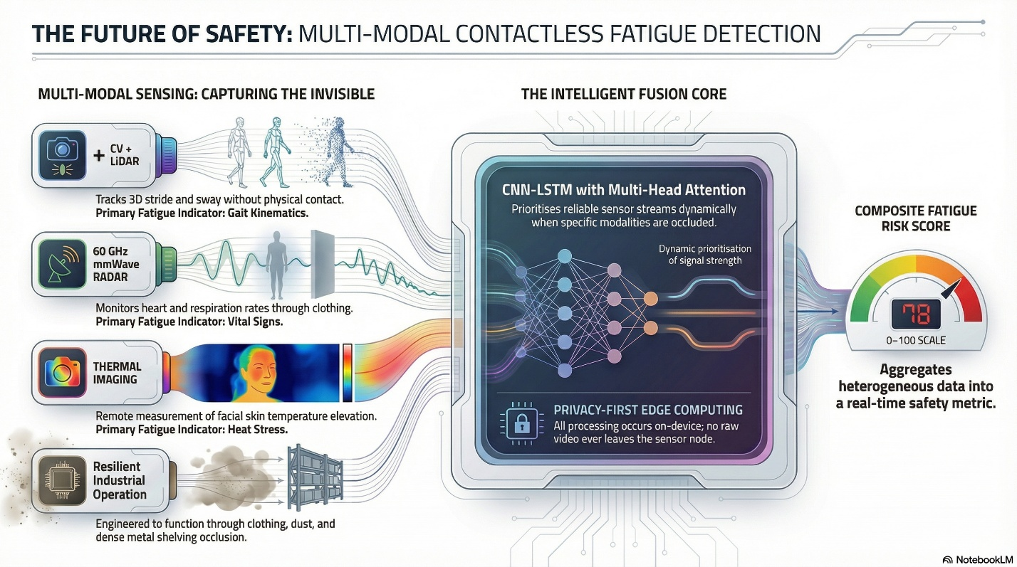

Time Schedule of Activities:
 | Time Schedule (in months)
Proposed Activity | 6 | 12 | 18 | 24 | 30 | 36
Objective 1: Sensor Node Design and Validation
Literature review and finalization of sensor specifications
Hardware procurement (AGX Orin, LiDAR, radar, thermal camera, sEMG/IMU sensors)
Sensor node mechanical design, assembly, and synchronization
Individual sensor calibration in controlled lab environment
Lab validation: CV and LiDAR gait extraction vs. motion capture
Lab validation: mmWave radar vs. ECG (quasi-static conditions)
Lab validation: thermal camera vs. contact thermometer
sEMG/IMU baseline data collection for physical ground truth
Objective 2: Fusion Algorithm Development
Feature engineering: CV, LiDAR, radar, thermal feature pipelines
Within-subject baseline normalization framework
CNN-LSTM asynchronous dual-rate fusion model development
Model training on lab validation data
Ablation study: single-modality and partial-fusion baselines
Optimization for Jetson AGX Orin (TensorRT conversion, latency benchmarking)
Objective 3: Field Validation and Privacy Compliance
Warehouse site selection and logistics partner engagement
Ethics committee approval and informed consent preparation
Sensor node installation and pilot testing at warehouse site
Field data collection: 30–50 workers, 5+ shifts each, PVT/KSS at 4 timepoints
sEMG/IMU subset validation (10–15 instrumented workers, first week)
FRS threshold calibration using ROC analysis
System performance evaluation (correlation, sensitivity, specificity, latency)
DPDP Act privacy compliance audit (face reconstruction, linkage attacks)
Dissemination and Documentation
Analysis of results and statistical validation
Compliance framework documentation
Manuscript preparation and submission
National/international conference presentation

Budget:
A. Equipment (Year 1):
Item | Specification | Cost (₹)
NVIDIA Jetson AGX Orin 64GB | 275 TOPS, primary edge processors for deployed nodes | ₹3,00,000
NVIDIA Jetson Orin Nano | Dev/testing secondary unit | ₹45,000
Livox Mid-360 LiDAR | Solid-state 3D, >100K pts/sec, IP67, multi-zone coverage | ₹2,85,000
TI IWR6843AOP mmWave Radar | 60 GHz FMCW, vital sign monitoring, lab + field sets | ₹2,10,000
FLIR Lepton 3.5 Thermal Camera | LWIR 8–14 µm, radiometric, 8.7 FPS | ₹1,20,000
IMX477 Global Shutter Camera | 12.3 MP, pose estimation optimised | ₹24,000
GPU Workstations – Primary | RTX 4090, 128 GB RAM, 8 TB NVMe SSD | ₹7,50,000
Data Server & Storage | 20 TB RAID, backup system | ₹1,15,000
Delsys Trigno sEMG System | Wireless EMG, 5-sensor kit, ground truth | ₹2,80,000
Xsens IMU Motion Capture | Full-body 17-sensor reference suit | ₹1,50,000
ECG Chest Straps | Polar H10 or equivalent | ₹50,000
PVT Tablets + App Licenses | Android, validated PVT software | ₹35,000
Environmental Sensors | BME280 temp/humidity/PM2.5 | ₹12,000
Mounting Hardware & Installation | Ceiling/pillar brackets, conduit, site cabling | ₹1,31,000
Equipment Subtotal (Year 1) |  | ₹28,50,000

Budget Head | Year 1 (₹) | Year 2 (₹) | Year 3 (₹) | Total (₹)
A. Equipment & Infrastructure | ₹28,50,000 | ₹3,00,000 | ₹1,35,000 | ₹32,85,000
B. Research Personnel | ₹9,04,800 | ₹9,51,600 | ₹9,82,800 | ₹28,39,200
C. Software & Cloud Services | ₹4,00,000 | ₹3,00,000 | ₹1,50,000 | ₹8,50,000
D. Consumables | ₹2,00,000 | ₹1,80,000 | ₹1,00,000 | ₹4,80,000
E. Travel | ₹50,000 | ₹2,50,000 | ₹2,60,000 | ₹5,60,000
F. Contingency (8%) | 3,52,000 | 1,59,000 | 1,30,000 | ₹5,58,000
Grand Total (before overhead) | 47,56,800 | 21,40,600 | 17,57,800 | 86,55,200
Overhead (20%, IIT Bombay norms) | — | — | — | 17,31,040
Three-Year Budget Summary

Budget Justification
A. Equipment and Infrastructure (₹32,85,000): The largest allocation is for equipment because the project requires building a complete multi-modal hardware platform from scratch. The NVIDIA Jetson AGX Orin (275 TOPS, 64 GB) is selected as the primary edge processor over entry-level alternatives based on published benchmarks demonstrating that concurrent LiDAR point cloud processing and camera-based pose estimation require substantially more compute and memory bandwidth than the Orin Nano can sustain. Two Jetson units are budgeted: one for the deployed sensor node and one for development and testing in parallel. Industrial-grade fanless enclosures rated to 60°C ambient are included to prevent thermal throttling during sustained 8-hour warehouse deployments. Multiple LiDAR and radar units support distributed monitoring across warehouse zones and provide redundancy for a mission-critical safety application. The GPU workstation is required for training the fusion model on multi-modal time-series data; the Jetson is sufficient for inference but not training. Validation equipment (sEMG system, IMU suit, ECG straps, PVT tablets) is essential for Objective 3, where the contactless system must be correlated against both cognitive and physical ground-truth references concurrently during warehouse shifts.

B. Research Personnel (₹28,39,200): Funds exactly one Post-Doctoral Researcher (Research Associate) for 3 years to handle deep learning fusion and field deployment. Calculated strictly per DST/SERB norms for IIT Bombay with 30% Mumbai HRA (Year 1: ₹58k base + 30% = ₹75,400/mo; Year 2: ₹61k base + 30% = ₹79,300/mo; Year 3: ₹63k base + 30% = ₹81,900/mo).
C. Software and Cloud Services (₹8,50,000): Algorithm development utilizes open-source frameworks (Python, PyTorch). AWS/Azure cloud credits support distributed model training runs and scalable data storage during the 3-week field study. Statistical software (SPSS/R) is needed for validation analysis (Pearson correlation, sensitivity-specificity). Secure data management services and VPN ensure DPDP Act 2023 compliance throughout the study.

D. Consumables (₹4,80,000): Electronic components and spares are budgeted for expected hardware attrition in the harsh warehouse environment (heat, dust, vibration). Safety equipment including PPE and first aid supplies is mandatory for industrial field trials.

E. Travel (₹5,60,000): Site visits to warehouses in the Mumbai, Pune, and Bhiwandi logistics corridor are weighted toward Year 2 when field validation occurs. One national conference per year (ICACCI, TENCON) is budgeted for interim results dissemination. One international conference in Year 3 (IEEE EMBC or ICASSP) targets the highest-impact venue for the field validation results. Patent filing costs are included in Year 3 for the fusion algorithm and privacy-preserving architecture.

F. Contingency (8%) and Overhead: An 8% contingency accounts for equipment price fluctuations. Participant incentives and refreshments for the 30 to 50 workers participating in the validation study. No personnel contingency is separately budgeted as personnel costs are fixed by contract. Institutional overhead is calculated at 20% of the total project cost as per IIT Bombay norms, bringing the total project outlay to approximately ₹1,03,86,240.

References:
[1] Yoshino K, Motoshige T, Araki T, Matsuoka K. Effect of prolonged free-walking fatigue on gait and physiological rhythm. Journal of Biomechanics, 2004; 37(8): 1271-1280. DOI: 10.1016/j.jbiomech.2003.11.031
[2] Stenum J, Rossi C, Roemmich RT. Two-dimensional video-based analysis of human gait using pose estimation. PLoS Computational Biology, 2021; 17(4): e1008935. DOI: 10.1371/journal.pcbi.1008935
[3] Shen C, Fan C, Wu W, et al. LidarGait: Benchmarking 3D Gait Recognition with Point Clouds. IEEE/CVF CVPR, 2023; 1054-1063. DOI: 10.1109/cvpr52729.2023.00108
[4] Ahmad A, Roh JC, Wang D, Dubey A. Vital signs monitoring of multiple people using a FMCW millimeter-wave sensor. IEEE Radar Conference, 2018; 1450-1455. DOI: 10.1109/radar.2018.8378778
[5] Alizadeh M, Shaker G, Almeida JCM, Morita PP, Safavi-Naeini S. Remote monitoring of human vital signs using mm-wave FMCW radar. IEEE Access, 2019; 7: 54958-54968. DOI: 10.1109/access.2019.2912956
[6] Papoutsakis K, Papadopoulos T, Maniadakis M, et al. Detection of physical strain and fatigue in industrial environments using visual and non-visual sensors. PETRA 2021, ACM; 270-271. DOI: 10.1145/3453892.3461633
[7] Jirak D, Belgiovine G, Eldardeer O, et al. Vision-based muscular fatigue detection for safe human-robot collaboration. Lecture Notes in Computer Science, Springer, 2025; 392-403. DOI: 10.1007/978-981-96-3525-2_33
[8] Bordallo López M, del-Blanco CR, García N. Detecting exercise-induced fatigue using thermal imaging and deep learning. IEEE IPTA, 2017; 1-6. DOI: 10.1109/ipta.2017.8310151
[9] Perpetuini D, Formenti D, Iodice P, et al. Central and peripheral thermal signatures of brain-derived fatigue during unilateral resistance exercise. Biology, 2022; 11(2): 322. DOI: 10.3390/biology11020322
[10] Venugopal V, Chinnadurai J, Lucas RAI, Kjellstrom T. Occupational heat stress profiles in selected workplaces in India. IJERPH, 2016; 13(1): 89. DOI: 10.3390/ijerph13010089
[11] Krishnamurthy M, Ramalingam P, Perumal K, et al. Occupational heat stress impacts on health and productivity in a steel industry in Southern India. Safety and Health at Work, 2017; 8(1): 99-104. DOI: 10.1016/j.shaw.2016.08.005
[12] Singh A, Anusha. The DPDP Act 2023: An ambitious government step towards ensuring its wide reach. Indian Journal of Public Administration, 2024; 70(3): 502-515. DOI: 10.1177/00195561241271533
[13] Mittal S. A survey on optimized implementation of deep learning models on the NVIDIA Jetson platform. Journal of Systems Architecture, 2019; 97: 428-442. DOI: 10.1016/j.sysarc.2019.01.011
[14] Hwang S, Kwon N, Lee D, et al. A multimodal fatigue detection system using sEMG and IMU signals with a hybrid CNN-LSTM-Attention model. Sensors, 2025; 25(11): 3309. DOI: 10.3390/s25113309
[15] Benny D, Srivastava A, et al. Design and measurements of mmWave FMCW radar based non-contact multi-patient HR and BR monitoring system. IEEE BioCAS, 2023.
[16] Srivastava A, et al. High-precision mmWave radar-based posture classification using edge AI. IEEE Sensors Journal, 2024.
[17] Cho K, et al. Effects of prolonged standing and walking on physiological and postural stability. Gait & Posture, 2015.
[18] Zheng WL, Lu BL. A multimodal approach to estimating vigilance using EEG and forehead EOG. Journal of Neural Engineering, 2017.
[19] Lubecke V, Boric-Lubecke O. Doppler Radar Physiological Sensing. Wiley, 2016.
[20] Zhang Z, et al. High-precision heart rate estimation using mmWave radar with DR-MUSIC algorithm. Scientific Reports, 2024; 14: 25535. DOI: 10.1038/s41598-024-77683-1

